

Project Name: “Movie Ticket Booking System”

Branch PG-DAC Sept-2023

Documentation On

**“Movie Dekho”**

PG-DAC September 2023

**Guided By: Dipali Jadhav**

Submitted By:

**Group No: 02**

* **Prathamesh Hanmante 230943020032**
* **Shubham Hazare 230943020089**
* **Shubham Yache 230943020090**
* **Abhishek Shujalpurkar 230943020120**

Table of Contents

1. Introduction 1

1.1 Document Purpose 1

1.2 Project Background 1

1.3 Aim & Objective 1

1.4 Customers and Stakeholders 1

2. Business Requirements Overview 2

3. Functional Requirements Overview 2

3.1 Customer Module 2

3.2 Theatre Admin Module 3

3.3 System Admin Module 3

4. Non-Functional Requirement 3

5. Use Case Diagram 4

6. Database Design 7

7. E-R Diagram: 10

8. Snapshots 11

***9. Conclusion………………………………………………………………….……………………………………………….17***

# **1. Introduction**

## 1.1 Document Purpose

This document communicates the business requirements and scope for developing Movie Ticket Booking System. The scope of this document is to define the functional and non-functional requirements, business rules and other constraints requirements.

## 1.2 Project Background

## The entertainment industry has witnessed a significant shift in consumer behaviour, with an increasing number of individuals preferring the convenience of online platforms for various services. One such sector that has embraced digital transformation is the cinema and movie ticket booking industry. Recognizing this trend, we embark on the development of a state-of-the-art Movie Booking Website to enhance the movie-going experience for audiences and streamline operations for cinemas.

## 1.3 Aim and Objective

## The Movie Ticket Booking System will serve as an online platform that allows users to browse movies, view showtimes, select seats, and book tickets across multiple theatres.

## The primary objectives of the Movie Ticket Booking System are as follows:

## Enhanced User Experience: Develop a user-friendly interface that allows users to easily browse movies, view showtimes and book tickets with minimal effort.

## Efficient Cinema Management: Provide cinema administrators with a centralized system to manage movie listings, showtimes, and seating arrangements.

## Promotions and Loyalty Programs: Implement features for cinemas to run promotions, discounts, enhancing customer engagement and retention.

## 1.4 Customers and Stakeholders

* **Customers:**
  + Users
* **Stakeholders:**
  + Users (Customers)
  + Theatre Administrators
  + System Administrators

# 

# **2. Business Requirements Overview**

* Movie Ticket Booking System is a public web application.
* This application will allow users to book their favourite movies remotely.
* Movie Ticket Booking System could be maintained by Administrator.

# **3. Functional Requirements Overview**

Movie Ticket Booking System consists of three modules described as below:

3.1 User Module

3.2 Theatre Administrator Module

* 1. System Administrator Module

## 3.1 User Module:

## User Registration and Authentication:

## Allowing users to register and login securely.

## Implement authentication mechanism to protect user information.

## Movie Listings:

## Display the available showing movies with filters like title genre rating and showtimes.

## Provide a search and filter options for users to find movies easily.

## Seat Selection:

## Enable users to select seats for a particular showtime.

## Booking:

## Allow users to book ticket for selected seats.

## Booking Confirmation:

## Provide booking details.

## Send confirmation email or message to users after booking.

## Booking Cancellation:

## Allow user to cancel a booking.

## 3.2 Theatre Administrator Module:

## Develop a secure administrative panel for theatre staff to manage movie listings, showtimes and seating arrangements.

## Ability to add, edit or remove movies, update showtimes and monitor bookings.

## 3.3 System Administrator Module:

## Regularly update and maintain the website’s content.

## Ability to add, edit or remove Theatre owner’s account.

# **4. Non-Functional Requirement**

* The website should use professional design, look and feel and color scheme.
* Users will have no limitations for accessing the application through Internet. The portal being an internet application, it is difficult specify exact number of visitor or users. Hence, we will target the system to support between 5 and 10 million users on launch of phase 1.
* Being a public website, the site must follow general usability guidelines for menus, navigation, colours, links and other actions provided on the screens.
* The system should be designed in such a manner that user will be able to complete tasks in minimum number of steps.

# **5. Use Case Diagram**

**5.1 User (Customer):**

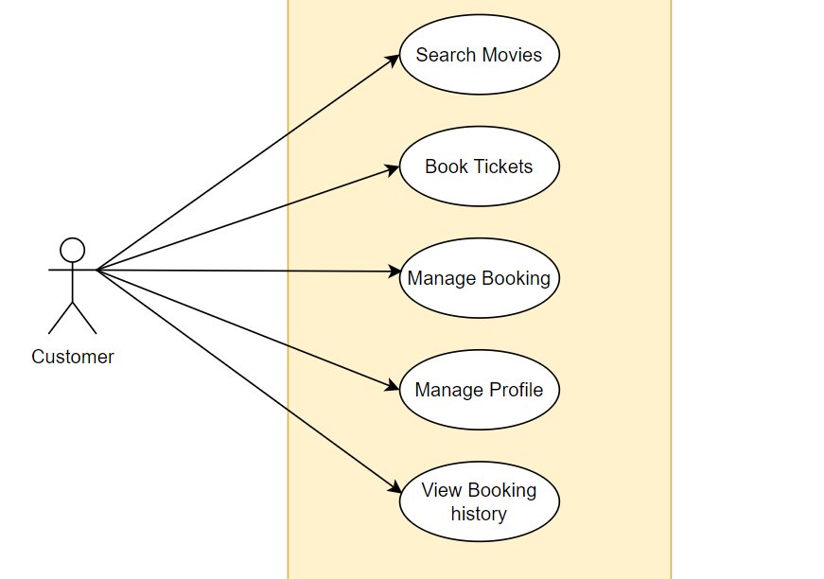

* 1. **Theater Administrator:**

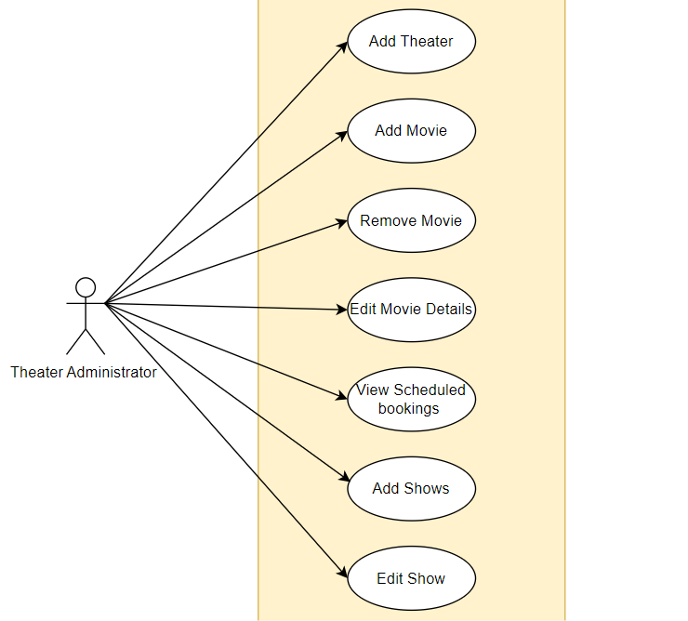

* 1. **System Administrator:**

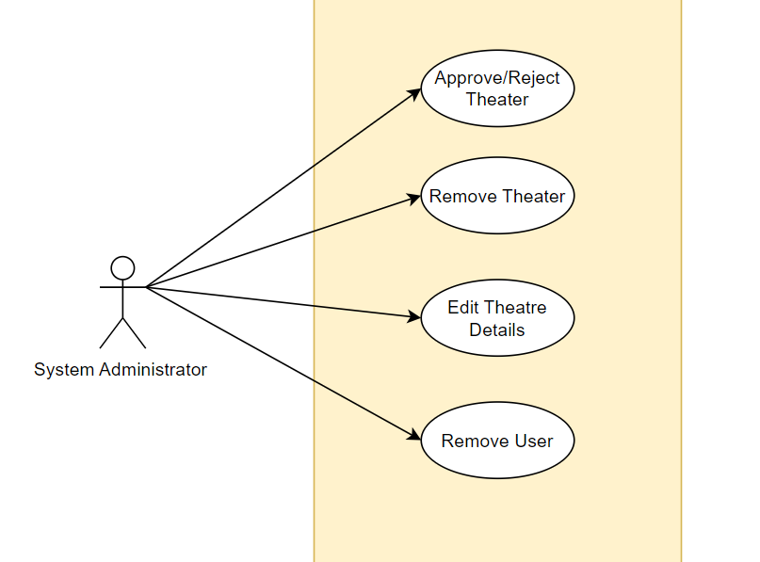

# **6. Database Design**

|  |  |  |  |  |  |
| --- | --- | --- | --- | --- | --- |
| **Booking** | | | | | |
| **Field** | **Type** | **Null** | **Key** | **Default** | **Extra** |
| Booking_id | INT | No | PK | NULL | Auto-Increment |
| user_id | INT | No | MUL | NULL |  |
| show_id | INT | No | MUL | NULL |  |
| amount | DECIMAL (10,2) | No |  | NULL |  |
| status | TINYINT | No |  | NULL |  |
| seat number | INT | No |  | NULL |  |

1. **Booking Table**
2. **Login Table**

|  |  |  |  |  |  |
| --- | --- | --- | --- | --- | --- |
| **Login** | | | | | |
| **Field** | **Type** | **Null** | **Key** | **Default** | **Extra** |
| login_id | INT | No | PK | NULL | Auto-Increment |
| username | VARCHAR (45) | No |  | NULL |  |
| password | VARCHAR (50) | No |  | NULL |  |
| role_id | INT | No |  | NULL |  |

1. **Movies Table**

|  |  |  |  |  |  |
| --- | --- | --- | --- | --- | --- |
| **Movies** | | | | | |
| **Field** | **Type** | **Null** | **Key** | **Default** | **Extra** |
| movie_id | INT | No | PK | NULL | Auto-Increment |
| title | VARCHAR (45) | No |  | NULL |  |
| director | VARCHAR (45) | No |  | NULL |  |
| release_date | DATE | No |  | NULL |  |
| genre | VARCHAR (45) | No |  | NULL |  |
| duration | INT | No |  | NULL |  |
| language | VARCHAR (45) | No |  | NULL |  |
| description | VARCHAR (450) | No |  | NULL |  |
| theatre_id | INT | No | MUL | NULL |  |
| image | LongBLOB | No |  | NULL |  |

1. **Role Table**

|  |  |  |  |  |  |
| --- | --- | --- | --- | --- | --- |
| **Role** | | | | | |
| **Fields** | **Type** | **Null** | **Key** | **Default** | **Extra** |
| role_id | INT | No | PK | NULL | Auto-Increment |
| role_name | VARCHAR (45) | No |  | NULL |  |

|  |  |  |  |  |  |
| --- | --- | --- | --- | --- | --- |
| **System Admin Table** | | | | | |
| **Field** | **Type** | **Null** | **Key** | **Default** | **Extra** |
| admin_id | INT | No | PK | NULL | Auto-Increment |
| admin_name | VARCHAR (45) | No |  | NULL |  |
| login_id | INT | No | MUL | NULL |  |

1. **System Admin Table**
2. **Theatre Table**

|  |  |  |  |  |  |
| --- | --- | --- | --- | --- | --- |
| **Theatre** | | | | | |
| **Field** | **Type** | **Null** | **Key** | **Default** | **Extra** |
| theatre_id | INT | No | PK | NULL | Auto-Increment |
| theatre_name | TINYINT (1) | No |  | NULL |  |
| theatre_location | INT | No |  | NULL |  |
| total_seats | INT | No |  | NULL |  |
| login_id | INT | No | MUL | NULL |  |
| theatre_status | TINYINT | No |  | 0 |  |
| owner_name | VARCHAR (50) | No |  | NULL |  |
| licence_no | VARCHAR (45) | No |  | NULL |  |
| email | VARCHAR (45) | No |  | NULL |  |
| phone_no | VARCHAR (45) | No |  | NULL |  |
| address | VARCHAR (45) | No |  | NULL |  |

1. **Tickets Table**

|  |  |  |  |  |  |
| --- | --- | --- | --- | --- | --- |
| **Tickets** | | | | | |
| **Field** | **Type** | **Null** | **Key** | **Default** | **Extra** |
| ticket_id | INT | No | PK | NULL | Auto-Increment |
| user_id | INT | No | MUL | NULL |  |
| movie_id | INT | No | MUL | NULL |  |
| theatre_id | INT | No | MUL | NULL |  |
| no_of_seats | INT | No |  | NULL |  |
| show_id | INT | No | MUL | NULL |  |
| total_amount | INT | No |  | NULL |  |

1. **Users Table**

|  |  |  |  |  |  |
| --- | --- | --- | --- | --- | --- |
| **Users** | | | | | |
| **Field** | **Type** | **Null** | **Key** | **Default** | **Extra** |
| User_id | INT | No | PRI | NULL | Auto-Increment |
| Name | VARCHAR (45) | No |  | NULL |  |
| Email | VARCHAR (50) | No |  | NULL |  |
| Phone_number | VARCHAR (10) | No |  | NULL |  |
| Address | VARCHAR (255) | No |  | NULL |  |
| Login_id | INT | No | UNI | NULL |  |

1. **Shows Table**

|  |  |  |  |  |  |
| --- | --- | --- | --- | --- | --- |
| **Shows** | | | | | |
| **Field** | **Type** | **Null** | **Key** | **Default** | **Extra** |
| Show_id | INT | No | PRI | NULL | Auto-Increment |
| Movie_id | INT | No | MUL | NULL |  |
| Theatre_id | INT | No | MUL | NULL |  |
| Show_date | DATE | No |  | NULL |  |
| Show_time | TIME | No |  | NULL |  |

# **7. E-R Diagram**

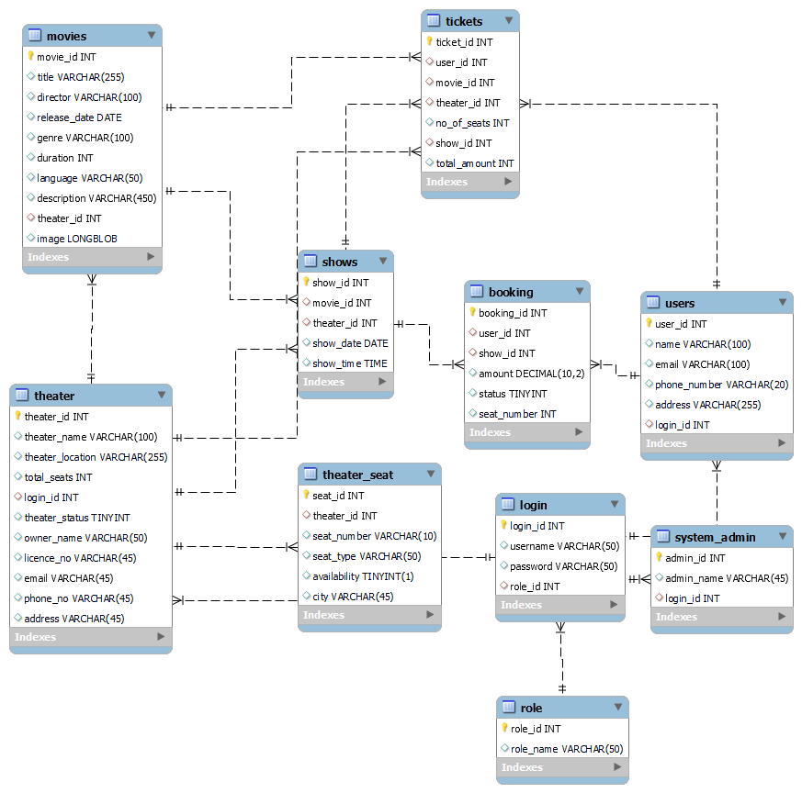

# **8. Snapshots**

**8.1 Home Page:**

Following snapshot shows the **Home Page** for Movie Ticket Booking Application before Login.

Guest user can navigate to Registration and Login page from Home Page.

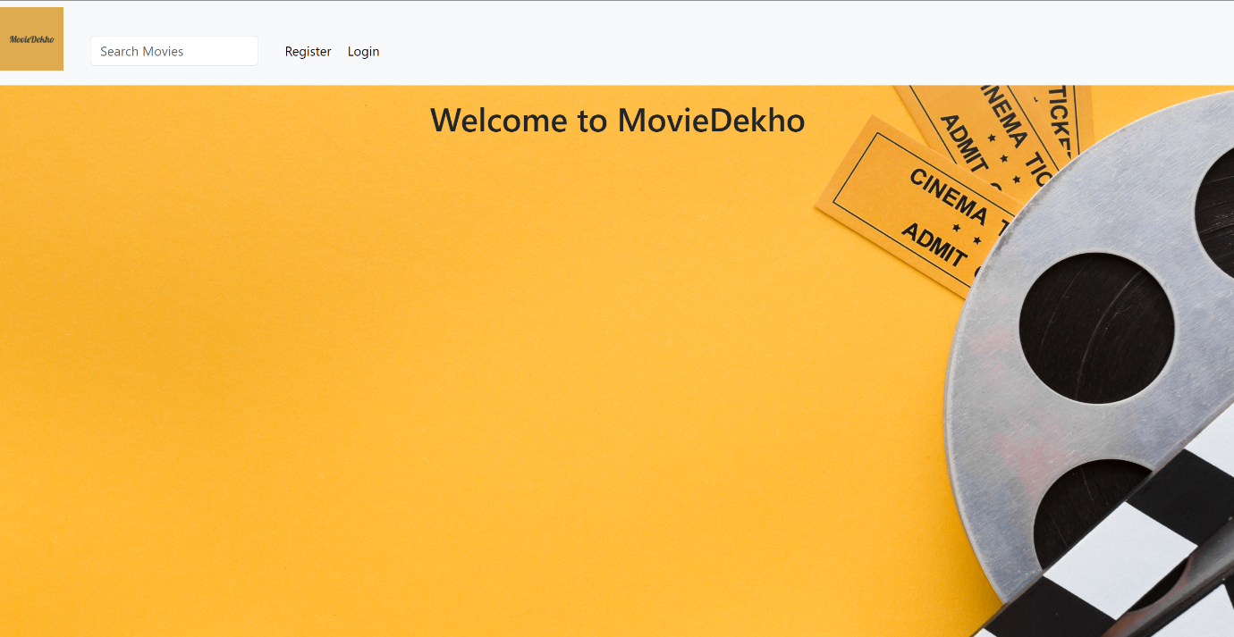

* 1. **Registration Page:**

Customer/Theatre Owner can register himself by navigating to registration page.

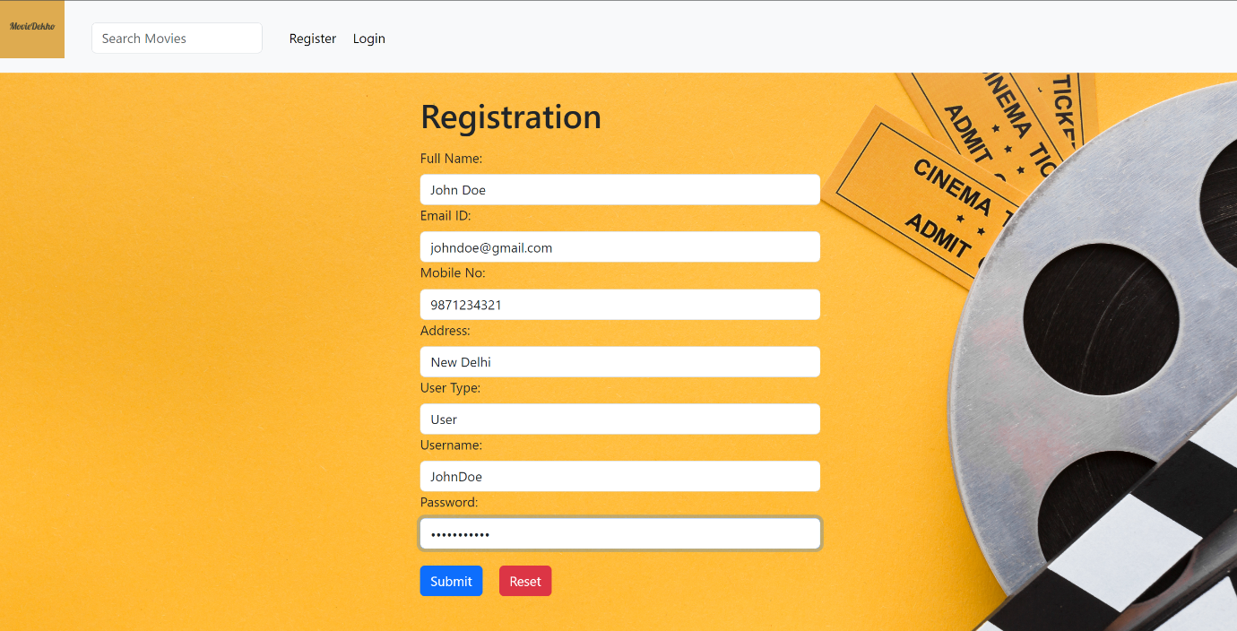

* 1. **Admin Home Page:**

**Admin** Dashboard after login. The admin can approve or deny the newly registered Theatre Owner.

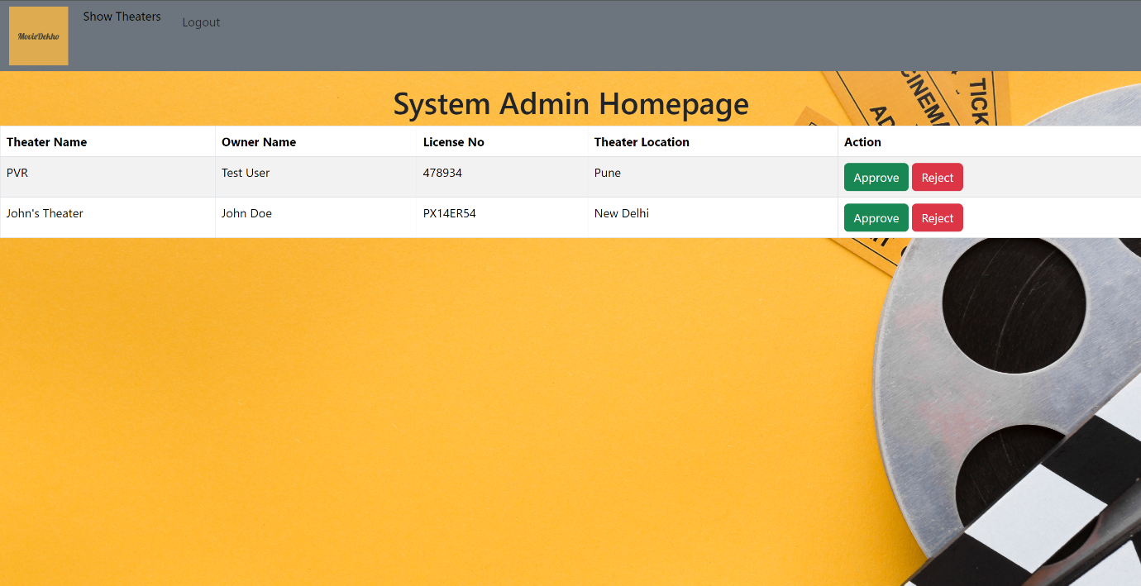

* 1. **Admin:**

**Admin** can restrict the theatres.

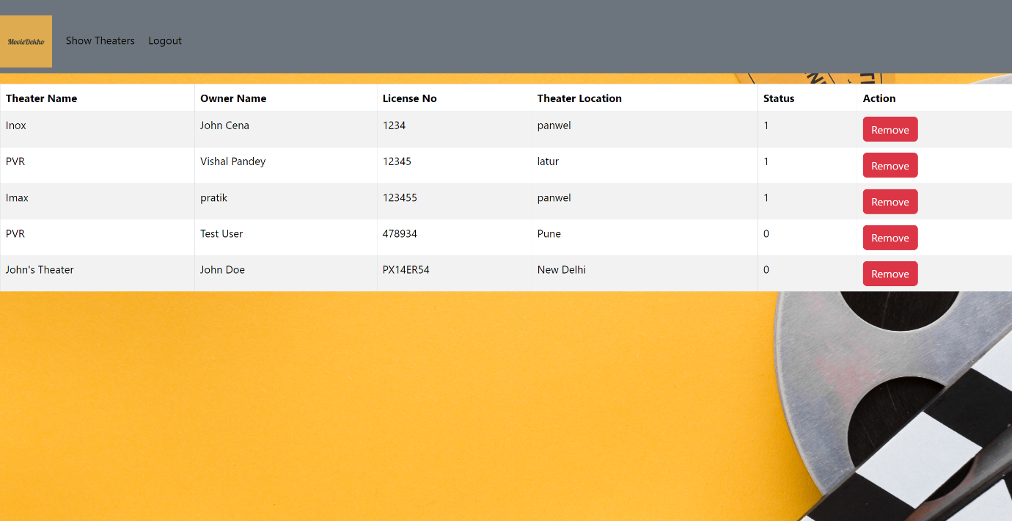

**8.5 Theatre Owner Home Page:**

Theatre owner can see this page after login Theatre owner can edit and remove delete movies.

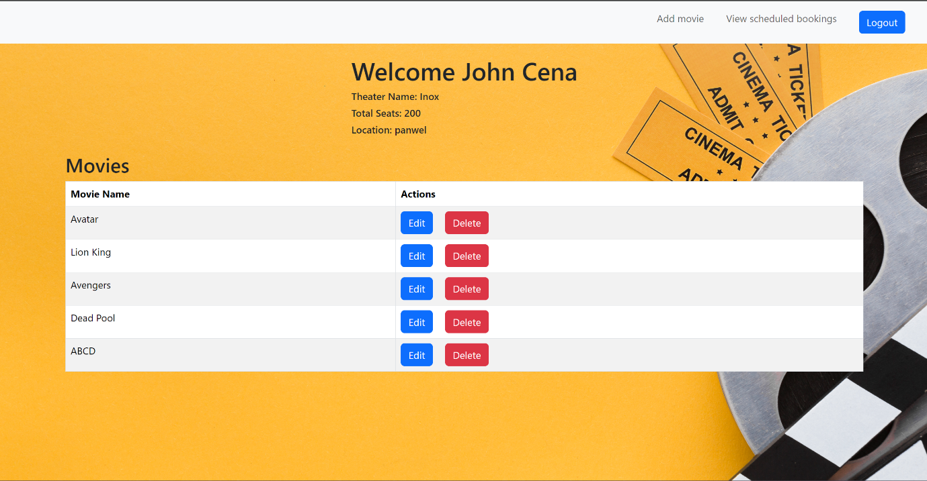

**8.6 Theatre owner:**

Theatre owner can add movie for their theatre.

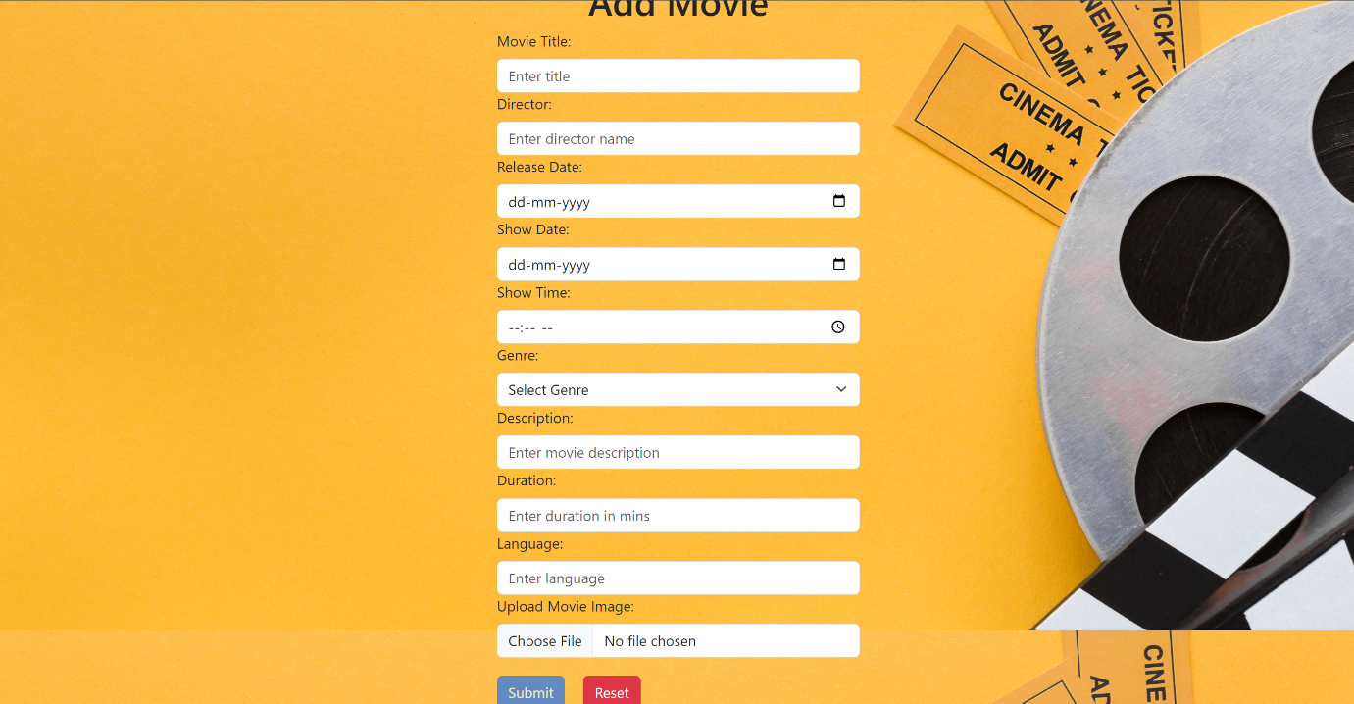

**8.7 User**:

User can see list of movies based on location after login.

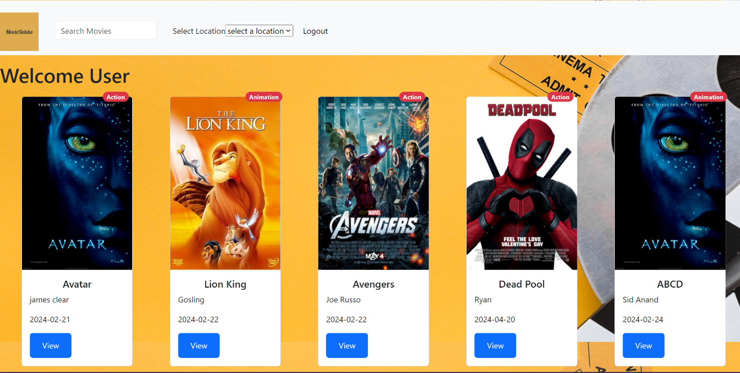

**8.8 Movie Details Page:**

After selecting movie by clicking view button.



* 1. **Theatre selection page:**

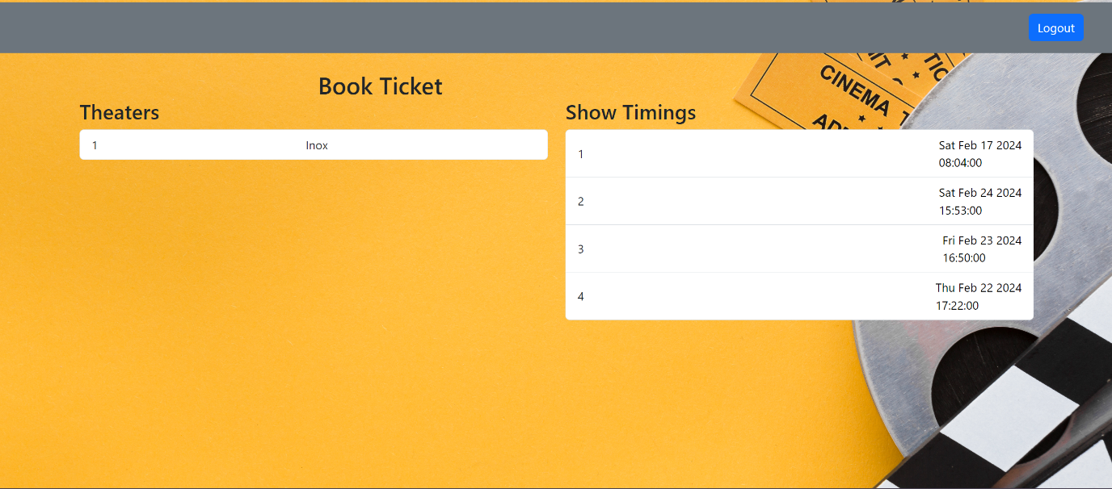

**8.10 Seat Picker:**

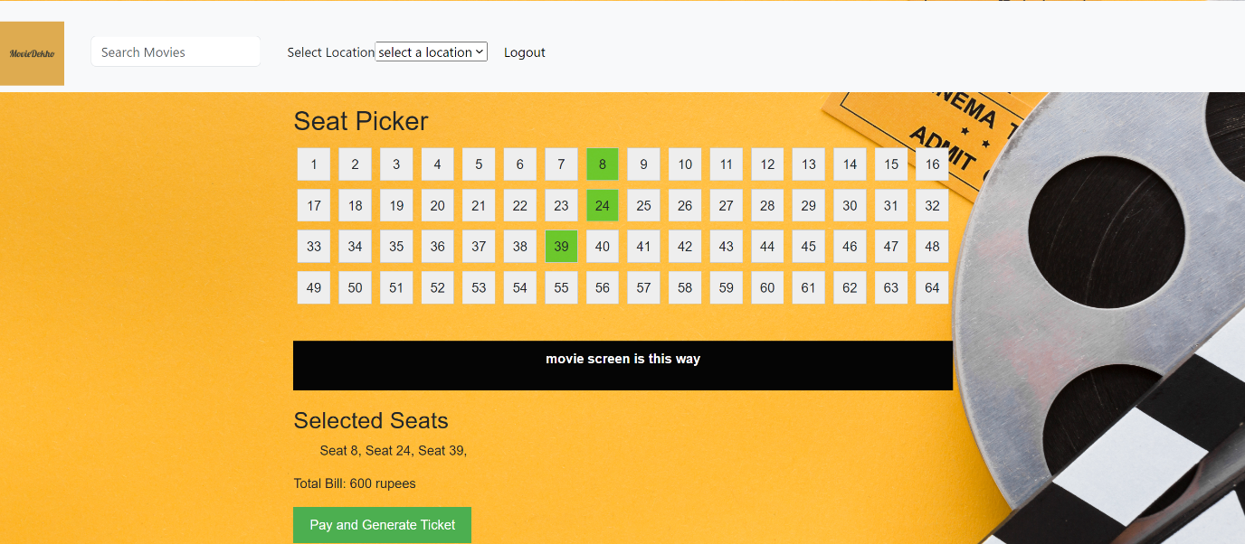

* 1. **Seat picker page when there are some seats already booked:**

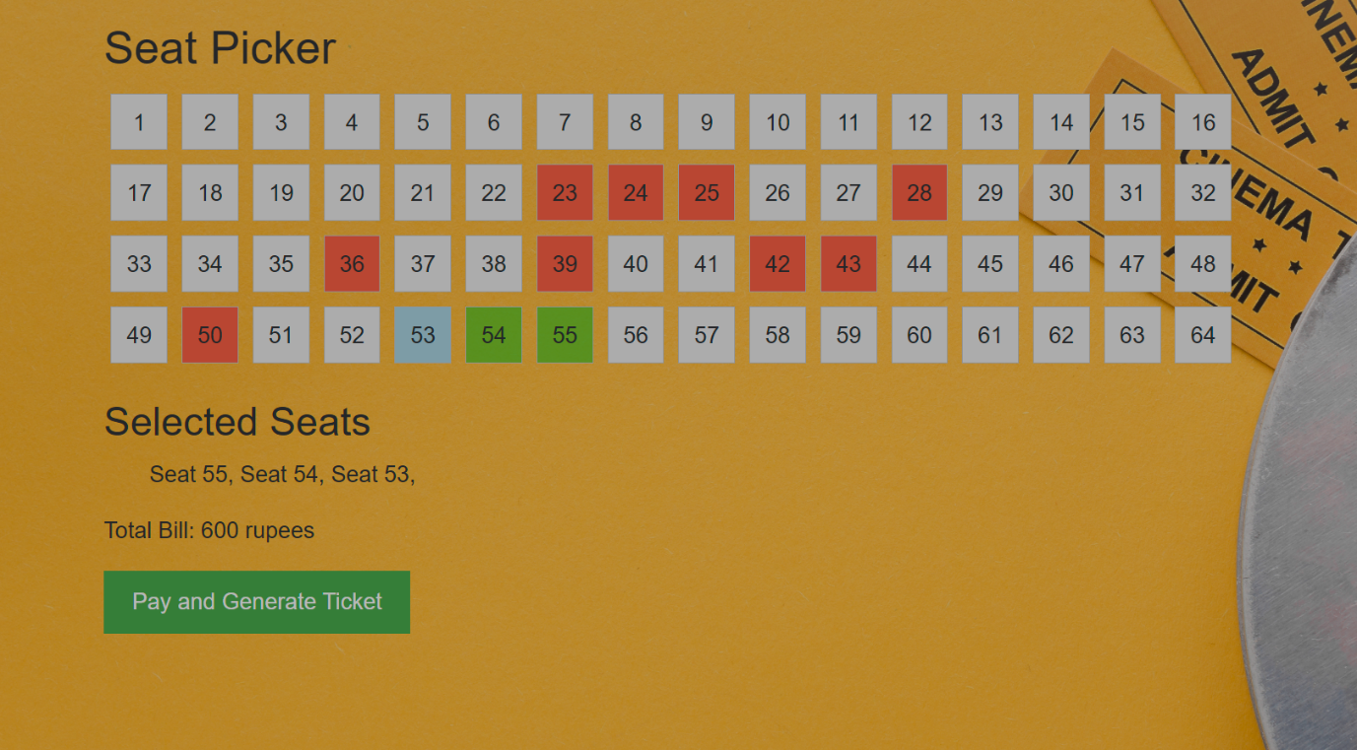

* 1. **Ticket confirmation Page:**

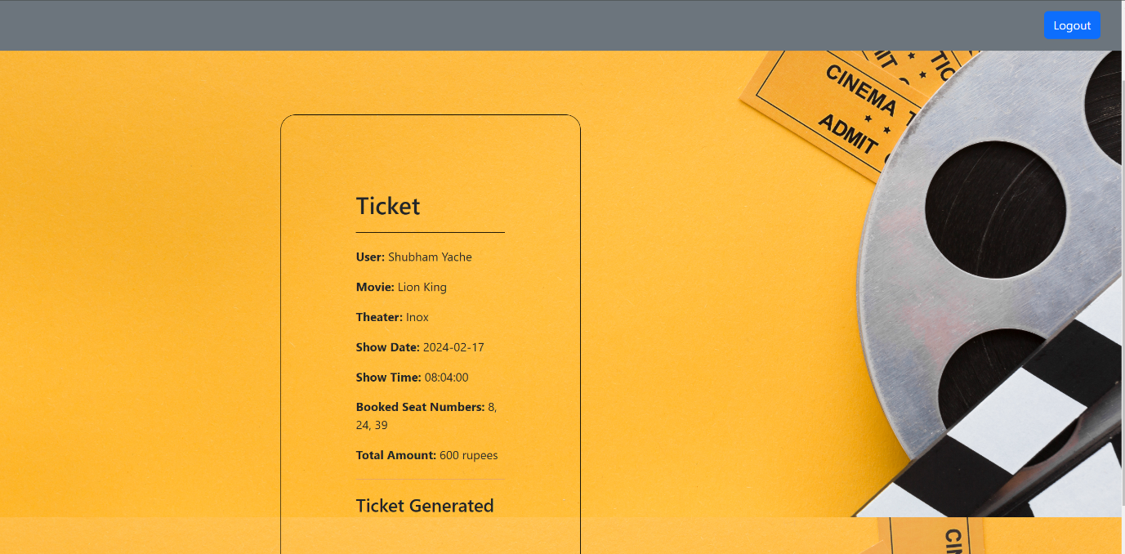

# **9. Conclusion:**

The “Movie Ticket Booking System” application aims to provide a comprehensive solution for individuals looking to have a quick, user friendly and hassle-free experience of booking movie tickets. As we move forward, we remain committed to further enhancing the website's functionality, expanding its features, and incorporating user feedback to meet the evolving needs of our audience. We believe that our movie ticket booking system website not only streamlines the ticket booking process but also contributes to the overall growth and development of the entertainment industry.